Department of Computing

CS250: Data Structure and Algorithms
Class: BSAI 2A
LAB 6
ALGORITHMIC COMPLEXITY & RECURRSION

Course Instructor: Mr. Saud Kamran
Lab Engineer: Hassan Mohtashim
NAME: Maira Qamar
REG NO: 551768

Introduction
Algorithmic complexity refers to the effectiveness of an algorithm in terms of resource consumption, primarily time and space, as the size of the input grows. It is crucial for developers and computer scientists to evaluate and optimize algorithms to ensure they can handle large datasets and complex problems efficiently.
Objectives
This lab will enable the students to analyze different algorithms and their analytical and asymptotic complexities.
Tools/Software Requirement
Visual Studio C++

Description
This lab focuses on the analytical techniques used to evaluate the time complexity of various code snippets, demonstrating how algorithmic efficiency can be assessed using Big O notation.
Lab Tasks

Task 1 - Student ID Search Using Linear Search

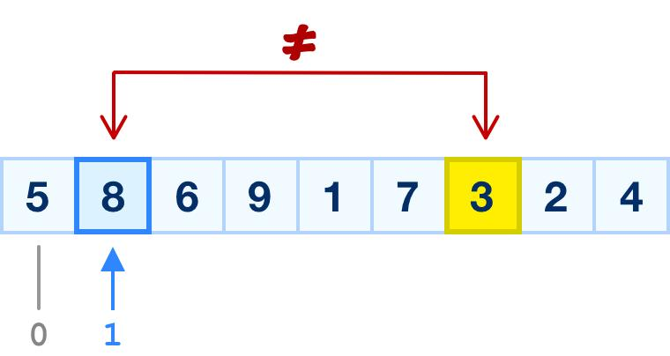
A university stores the student IDs of students registered in a laboratory session in a one-dimensional array. The IDs are not necessarily sorted.
Write a program that accepts n student IDs and a target ID. Search for the target using linear search, checking elements one by one from the beginning of the array.
If the ID is found, display its index. Otherwise, display a message stating that the ID is not registered.
Functions to implement
Function | Description
inputIDs() | Reads student IDs into the array.
linearSearch(arr, n, target) | Returns the index of the target or -1 if absent.
displayResult(index) | Displays the search result.
Justify the time complexity of Best, Average, and Worst case.
Implementation guidelines and concerns
- Use an array and a loop from index 0 to n - 1.
- Return immediately when the target is found.
- Return -1 if the loop finishes without a match.
- Handle an empty array and repeated IDs. If repeated IDs are allowed, specify whether the first occurrence is sufficient.
- Do not sort the array because the task is intended to demonstrate linear search on unsorted data.

CODE:
#include <iostream>
using namespace std;

const int MAX_SIZE = 1000;

int inputIDs(int arr[], int n) {
for (int i = 0; i < n; i++) {
cout << "Enter student ID " << i + 1 << ": ";
cin >> arr[i];
}
return n;
}

int linearSearch(int arr[], int n, int target) {
for (int i = 0; i < n; i++) {
if (arr[i] == target) {
return i;
}
}
return -1;
}

void displayResult(int index) {
if (index == -1) {
cout << "Student ID is not registered." << endl;
}
else {
cout << "Student ID found at index " << index << endl;
}}

int main() {
int arr[MAX_SIZE];
int n, target;

cout << "Enter number of students (0-1000): ";
cin >> n;

if (cin.fail() || n < 0 || n > MAX_SIZE) {
cout << "Invalid array size." << endl;
return 1;
}

inputIDs(arr, n);

cout << "Enter target student ID: ";
cin >> target;

int index = linearSearch(arr, n, target);
displayResult(index);

return 0;}

Test cases
Input array | Target | Expected result
[10, 20, 30, 40] | 10 | Index 0
[10, 20, 30, 40] | 30 | Index 2
[10, 20, 30, 40] | 50 | Not found
[7] | 7 | Index 0
[] | 5 | Not found
SCREENSHOT:
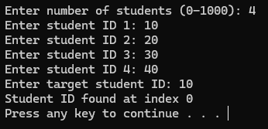
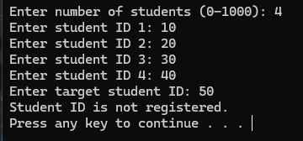
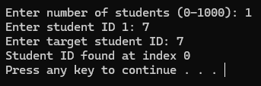
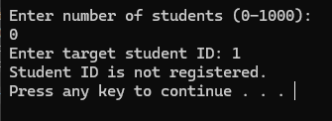

Task 2 - Sort Student Marks Using Merge Sort

A university maintains student registration numbers in ascending order. Given the sorted array and a registration number to search for, implement binary search to find its index.
Instead of checking every element, the algorithm examines the middle element and discards half of the remaining search range after each comparison.
Example:
Registration IDs: 10, 20, 30, 40, 50, 60, 70
Target ID: 60

Output: Found at index 5
The program must use an iterative or recursive binary search implementation. Students should state which version they chose and explain its complexity.
Functions to implement
Function | Description
inputSortedIDs(arr, n) | Reads the registration numbers in ascending order.
binarySearch(arr, low, high, target) | Returns the target index or -1 if absent.
isSorted(arr, n) | Checks whether the input is sorted in non-decreasing order.
Justify the time complexity of Best, Average, and Worst case.
Implementation guidelines and concerns
- Calculate the middle index using low + (high - low) / 2.
- If the middle element matches the target, return its index.
- If the target is smaller, search the left half; otherwise, search the right half.
- Ensure the search range shrinks on every iteration or recursive call.
- Validate that the array is sorted. Binary search does not work correctly on arbitrary unsorted input.
- If duplicate IDs are permitted, specify whether any occurrence or the first occurrence should be returned. The basic version may return any occurrence.

Test cases
Sorted array | Target | Expected result
[10,20,30,40,50] | 30 | Index 2
[10,20,30,40,50] | 10 | Index 0
[10,20,30,40,50] | 50 | Index 4
[10,20,30,40,50] | 25 | Not found
[7] | 7 | Index 0
[] | 5 | Not found
CODE:
#include <iostream>
using namespace std;

const int MAX_SIZE = 1000;

void inputSortedIDs(int arr[], int n) {
for (int i = 0; i < n; i++) {
cout << "Enter registration number " << i + 1 << ": ";
cin >> arr[i];
}
}

bool isSorted(int arr[], int n) {
for (int i = 1; i < n; i++) {
if (arr[i] < arr[i - 1]) {
return false;
}
}
return true;
}

int binarySearch(int arr[], int low, int high, int target) {
while (low <= high) {
int mid = low + (high - low) / 2;

if (arr[mid] == target) {
return mid;
}

if (target < arr[mid]) {
high = mid - 1;
}
else {
low = mid + 1;
}
}

return -1;
}

int main() {
int arr[MAX_SIZE];
int n, target;

cout << "Enter number of students (0-1000): ";
cin >> n;

if (cin.fail() || n < 0 || n > MAX_SIZE) {
cout << "Invalid array size." << endl;
return 1;
}

inputSortedIDs(arr, n);

if (!isSorted(arr, n)) {
cout << "Error: IDs must be in ascending order." << endl;
return 1;
}

cout << "Enter target registration number: ";
cin >> target;

int index = binarySearch(arr, 0, n - 1, target);

if (index == -1) {
cout << "Registration number not found." << endl;
}
else {
cout << "Found at index " << index << endl;
}

return 0;
}

SCREENSHOT:
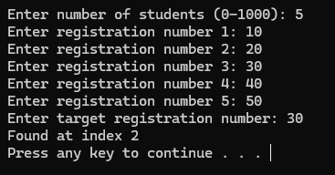
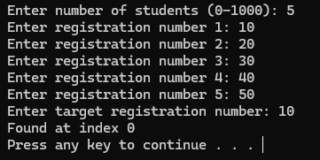
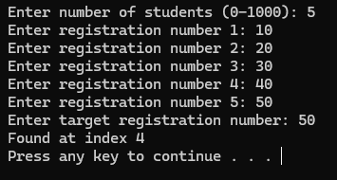
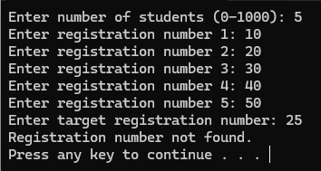
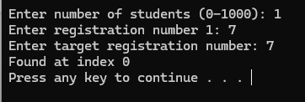
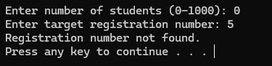

Task 3 - Sort Student Marks Using Merge Sort
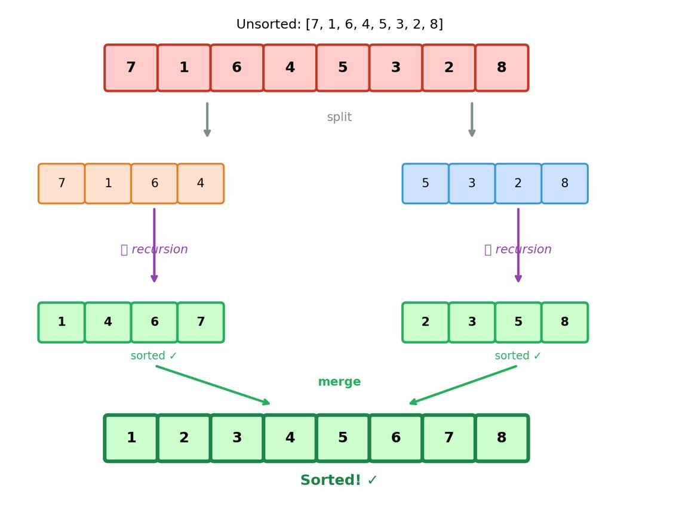
A teacher needs to sort the marks of students in ascending order before generating a merit list.
Implement merge sort, a divide-and-conquer sorting algorithm, to arrange the marks.
The algorithm must recursively divide the array into smaller subarrays until each subarray contains one element. It must then merge the subarrays in sorted order.
Example:
Input: 45, 12, 78, 33, 20, 60
Output: 12, 20, 33, 45, 60, 78
Your implementation must use merge sort rather than a built-in sorting function.
Functions to implement
Function | Description
mergeSort(arr, left, right) | Recursively divides and sorts the array.
merge(arr, left, mid, right) | Merges two sorted subarrays into one sorted range.
displayArray(arr, n) | Displays the array before and after sorting.
Justify the time complexity of Best, average, and worst cases.
Implementation guidelines and concerns
- Use left, mid, and right indices to define each subarray.
- The base case is reached when left >= right.
- Recursively sort the left half and the right half.
- During merging, compare the smallest remaining elements from both halves.
- Copy any remaining elements into the merged range.
- Ensure that the merge operation does not overwrite values before they have been used.
- Test the implementation with repeated values and arrays of length zero or one.
Test cases
Input | Expected output
[45,12,78,33,20,60] | [12,20,33,45,60,78]
[1,2,3,4] | [1,2,3,4]
[9,7,5,3,1] | [1,3,5,7,9]
[5,2,5,1,2] | [1,2,2,5,5]
[8] | [8]
[] | []
CODE:

#include <iostream>
using namespace std;

const int MAX_SIZE = 1000;

void displayArray(int arr[], int n) {
cout << "[";
for (int i = 0; i < n; i++) {
cout << arr[i];
if (i < n - 1) {
cout << ", ";
}
}
cout << "]" << endl;
}

void merge(int arr[], int left, int mid, int right) {
int n1 = mid - left + 1;
int n2 = right - mid;

int* L = new int[n1];
int* R = new int[n2];

for (int i = 0; i < n1; i++) {
L[i] = arr[left + i];
}

for (int j = 0; j < n2; j++) {
R[j] = arr[mid + 1 + j];
}

int i = 0;
int j = 0;
int k = left;

while (i < n1 && j < n2) {
if (L[i] <= R[j]) {
arr[k++] = L[i++];
}
else {
arr[k++] = R[j++];
}
}

while (i < n1) {
arr[k++] = L[i++];
}

while (j < n2) {
arr[k++] = R[j++];
}

delete[] L;
delete[] R;
}

void mergeSort(int arr[], int left, int right) {
if (left >= right) {
return;
}

int mid = left + (right - left) / 2;

mergeSort(arr, left, mid);
mergeSort(arr, mid + 1, right);

merge(arr, left, mid, right);
}

int main() {
int arr[MAX_SIZE];
int n;

cout << "Enter number of students (0-1000): ";
cin >> n;

if (cin.fail() || n < 0 || n > MAX_SIZE) {
cout << "Invalid array size." << endl;
return 1;
}

for (int i = 0; i < n; i++) {
cout << "Enter marks of student " << i + 1 << ": ";
cin >> arr[i];
}

cout << "Before sorting: ";
displayArray(arr, n);

if (n > 0) {
mergeSort(arr, 0, n - 1);
}

cout << "After sorting: ";
displayArray(arr, n);

return 0;
}
SCREENSHOT:
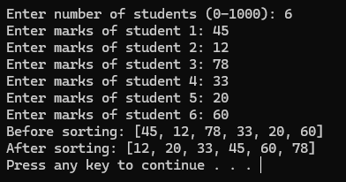
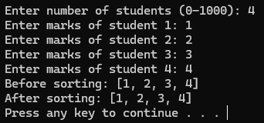
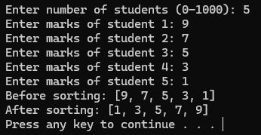
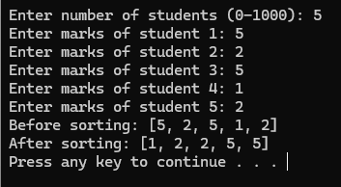
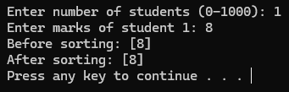
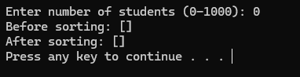

Task 4 - Knight’s Tour Using Recursive Backtracking
Data Structures: 2D Array and Recursion Stack
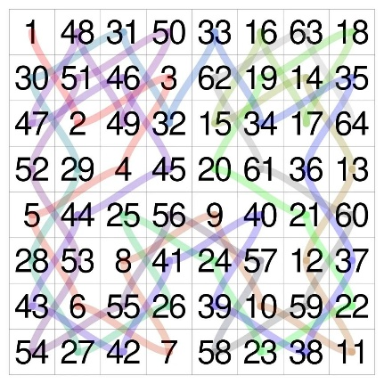
The Knight’s Tour is a classical chessboard problem in which a knight must visit every square exactly once.
A knight moves in an L-shape: two squares in one direction and one square perpendicular to that direction. From a given position, it can have up to eight possible moves.
Given a chessboard of size \(N \times N\) and a valid starting position \((x,y)\), design and implement a recursive backtracking algorithm that attempts to find one valid Knight’s Tour.
For example, on a 5 X 5 board, the program should attempt to number the squares from 1 to 25 in the order in which the knight visits them. Each consecutive number must represent a legal knight move.
If a valid tour is not found after exploring all possible moves, the program must report that no tour was found by the search.
2. Implementation Requirements
- Accept the board size N and the starting position from the user.
- Initialize an N X N board with unvisited values, such as -1.
- Define the eight possible knight moves using row and column offsets.
- Implement a recursive function such as solveKnightTour (row, col, moveNumber).
- Mark the current square with its move number.
- Use a base case that returns success when all N^2 squares have been visited.
- For each recursive call, consider the possible knight moves and reject moves that are outside the board or visit an already visited square.
- If a move leads to a dead end, undo the move by restoring the square to its unvisited state.
- Stop when a valid tour is found or all valid possibilities have been exhausted.
- Analyze the time and auxiliary space complexity, including the effect of backtracking.
Important: Ordinary recursive backtracking does not guarantee O(N^2) running time. A search heuristic may improve practical performance, but it does not automatically provide that worst-case guarantee.
3. Implementation Steps
1. Initialize the board: Create an N X N array and mark all squares as unvisited.
2. Define the moves: Store the eight possible row and column offsets in two arrays, such as dx[] and dy[].
3. Mark the current position: Assign the current move number to the square occupied by the knight.
4. Check the base case: If all N^2 squares have been visited, return success.
5. Explore candidate moves: For each of the eight possibilities, calculate the new position and check whether it is inside the board and unvisited.
6. Make a recursive call: Mark the candidate square and recursively attempt to complete the tour from that position.
7. Backtrack when necessary: If the recursive call fails, unmark the candidate square and try the next possible move. This restores the board to its previous state.
8. Display the result: Print the numbered board if a tour is found; otherwise, report that no tour was found for the specified search.
4. Recursion Analysis
The algorithm explores a search tree in which each level represents a knight’s move. A move is accepted only if the destination square is valid and unvisited.
- Base case: All N^2 squares have been visited, so the algorithm returns success.
- Recursive case: The algorithm tries each legal, unvisited knight move and recursively searches for a complete tour.
- Backtracking case: If a move cannot lead to a complete tour, the algorithm restores the square to its unvisited state and tries another move.
- Failure condition: The algorithm returns failure when no legal unvisited move can complete the tour from the current position.
For a simple worst-case upper bound, there are at most eight candidate moves at each of at most N^2 levels. Therefore, a loose upper bound on the search time is:
O(8^{N^2})
This is a deliberately loose upper bound, not a claim that every input requires this much work. The actual number of explored states depends on the board, starting position, and pruning strategy.
Justify the best, average and worst case time complexities.

Complexity Analysis

Time Complexity Justification
- Best Case (O(N^2)):
The best-case scenario occurs when the very first path chosen by the algorithm at every single step leads directly to a valid, complete tour without hitting any dead ends or requiring backtracking. In this optimal scenario, the algorithm makes exactly one successful transition per square, resulting in linear time relative to the number of squares (N^2).
- Average Case (O(b^{N^2}) where 1 < b < 8):
The average case is exponential because the algorithm generally has to test multiple paths and handle dead ends before finding a solution. While the maximum branching factor is 8, many moves are immediately invalid (out of bounds or already visited), reducing the effective average branching factor to b. For small boards (such as 5 x 5), solutions can be found relatively quickly, but without search heuristics (like Warnsdorff's rule), the search space grows rapidly.
- Worst Case (O(8^{N^2})):
The worst-case scenario occurs when the algorithm exhausts nearly the entire search tree—testing all 8 possible moves at each of the N^2 levels—before either finding a solution or determining that none exists. This creates a massive search tree of height N^2 with up to 8 branches per node.

Auxiliary Space Complexity (O(N^2))
- Recursion Stack: The maximum depth of the recursive call stack is N^2because the knight must visit every single square on the board before the base case is reached.
- Board Storage: The N x N 2D vector used to store the visit order takes O(N^2) space.
- Overall Space: Combining the stack depth and the board representation yields an auxiliary space complexity of O(N^2).
CODE:
#include <iostream>
#include <vector>
#include <iomanip>

using namespace std;

const int cx[8] = { 2, 1, -1, -2, -2, -1, 1, 2 };
const int cy[8] = { 1, 2, 2, 1, -1, -2, -2, -1 };

bool isValid(int x, int y, int n, const vector<vector<int>>& board) {
return (x >= 0 && x < n && y >= 0 && y < n && board[x][y] == -1);
}

bool solveKnightTourUtil(int x, int y, int moveCount, vector<vector<int>>& board, int n) {
if (moveCount == n * n) {
return true;
}

for (int i = 0; i < 8; i++) {
int nextX = x + cx[i];
int nextY = y + cy[i];

if (isValid(nextX, nextY, n, board)) {
board[nextX][nextY] = moveCount;
if (solveKnightTourUtil(nextX, nextY, moveCount + 1, board, n)) {
return true;
}
board[nextX][nextY] = -1;
}
}

return false;
}

void printBoard(const vector<vector<int>>& board, int n) {
for (int i = 0; i < n; i++) {
for (int j = 0; j < n; j++) {
cout << setw(4) << board[i][j];
}
cout << "\n";
}
}

int main() {
int n;
cout << "Enter board size N: ";
cin >> n;

if (n < 1) {
cout << "Invalid board size!\n";
return 1;
}

int startX, startY;
cout << "Enter starting position (row and col, 0-indexed): ";
cin >> startX >> startY;

if (startX < 0 || startX >= n || startY < 0 || startY >= n) {
cout << "Error: Starting position is outside the board bounds!\n";
return 1;
}

vector<vector<int>> board(n, vector<int>(n, -1));

board[startX][startY] = 0;

if (solveKnightTourUtil(startX, startY, 1, board, n)) {
cout << "\nKnight's Tour successfully found:\n";
printBoard(board, n);
}
else {
cout << "\nNo valid Knight's Tour found for the specified starting position.\n";
}

return 0;
}

SCREENSHOT:
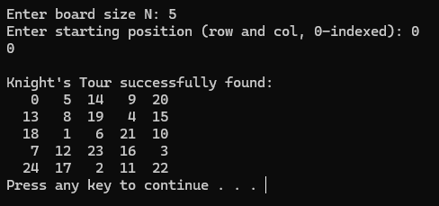
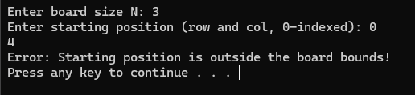

GITHUB LINK:

Grading Criteria for Lab
The grading for this lab will be done on the rubric given below. The final marks for the lab will be scaled to match other labs.
Assessment | CLO | ACTIVITY | Exceeds  Expectation 5 | Satisfactory 4 | Meets Expectation 3 | Needs  Improvement  2 | Unsatisfactory 1
General | CLO 4 | Adherence To  Ethical Coding  Practices | Demonstrates full commitment to  coding standards (clear comments, design, consistent formatting) and ensures ethical considerations. | Generally, follows coding standards and ethical practices, with minor lapses in documentation or clarity. | Follows basic coding standards but lacks attention to detail (e.g., insufficient comments or unclear design). | Inconsistent application of coding standards, some sections poorly documented or formatted. | Does not follow coding standards, poor  documentation, or engages in unethical practices (e.g., copying code).
Algorithm  Development for Peak Element | CLO 2 | O(n log n)  Algorithm for Peak Element | Develops a correct and efficient O(n log n) algorithm,  providing a  comprehensive explanation of the approach. | Develops a mostly correct algorithm with minor inefficiencies or lacks some details in explanation. | Basic algorithms are present but do not meet the O(n log n) requirement or lacks clarity. | Major issues with the algorithm; does not approach O(n log n) complexity or lacks logical structure. | No algorithm provided or completely incorrect approach to finding a peak element.
Knight's Tour Implementation | CLO 1 | Backtrack Optimization | Writes a valid backtracking algorithm for the Knight's Tour, optimizes to O(N²) and provides clear algorithmic complexity discussions. | Writes a mostly valid backtracking algorithm with minor optimization issues or unclear complexity analysis. | Basic implementation  exists but fails to optimize to O(N²) or lacks logical flow. | Major issues in implementation; do not approach O(N²) complexity or lacks proper analysis. | Fails to implement Knight's Tour; no valid algorithm or complexity analysis provided.
Tower of Hanoi Solution | CLO 1 | Iterative Solution | Develops a clear iterative solution for the Tower of Hanoi with accurate move sequences and complexity discussion. | Develops a mostly correct solution with minor errors in move sequences or complexity analysis. | Basic solution is present but lacks clarity or contains significant errors in logic. | Major issues in implementation; do not provide a clear iterative approach or complexity discussion. | Fails to implement Tower of Hanoi; no valid algorithm or complexity analysis provided.

